
Project id: 2025PJ-IT01
Synopsis
on
Non-Governmental Organization funding with Blockchain
Bachelor of Technology
Information Technology
By
Himanshu Vashistha: 2102900130022
Sharad Singhal: 2102900130038
Deepanshu Kumar: 2102900130015

Under the Supervision of
Prof. Dr. Sumit Kumar

ABES INSTITUTE OF TECHNOLOGY, GHAZIABAD



AFFILIATED TO
Dr. A.P.J. ABDUL KALAM TECHNICAL UNIVERSITY
LUCKNOW, UTTAR PRADESH

(December 2024-25)

INDEX
- Objective and Problem Statement 3
- Abstract 4
- Introduction 5
- Brief Literature Survey 10
- DFD/ER-diagram/Use Case 11
- Tools and Techniques used for the project 12
- Module 13
- References 14

Problem Statement
Current NGDs' transaction systems are inefficient and vulnerable to fraud and lack of transparency. Transactions are expensive, prone to fraud, and lack transparency. Blockchain has been identified as a decentralized method to ensure secure, tamper-proof, and transparent transactions. This will increase security, reduce costs, and increase donor confidence. Thus, the funding system will be efficient.

Objective
- Enhance transparency and security in NGO transactions using blockchain technology.
- Minimize fraud and operational inefficiencies through decentralized, tamper-proof systems.
- Improve donor confidence and streamline funding processes for NGOs.

Abstract
Although a relationship between NGOs and their donors is based more on trust, this time, donors would expect NGOs to demonstrate legitimacy and accountability. Transparency is central to building such trust, and the recent steps of technological advancement, especially blockchain, open innovative opportunities for increasing accountability in the NGOs sector. Blockchain acts as a distributed ledger that can validate transactions without involving the expertise of a trusted third party thus creating confidence between NGOs and its donors. There are many critical aspects found concerning blockchain's implementation in the NGOs sector, and a huge research gap exists regarding an effective understanding of blockchain compared to alternative methods that prove its efficiency in enhancing transparency and accountability. Although the statistics of research show a level of almost 95% effectiveness in making the processes for tracking donations more reliable through blockchain, yet 90% of NGOs are not open to such technologies. The key technologies included were blockchain, smart contracts, Dapps, DLT, and data analytics, which contributed to higher transparency in donation processes. Although the impressive promise blockchain presents in rebasing NGOs’ interactions with donors, some huge challenges organizations will have to surmount when implementing blockchain will come in because of the nature of the challenges- resistance to change and complexity in the handling of new technologies. This paper postulates that there is an imperative need for much more research concerning how such challenges may be surmounted and blockchain effectively wielded for transparency and accountability in the NGOs world.

Introduction
More recently, experience has shown that the implementation of blockchain technology and the NGO sector are under much closer scrutiny, especially in matters related to processes regarding improved transparency in donation. This is because the relationship between the NGOs and the donors is based on trust. The expectation from the donors is that the NGO will utilize the contributions effectively and responsibly. Nevertheless, fraud, a lack of transparency, and problems traced to the source of donation have halted the sector. Innovations towards these problems are therefore in high demand.
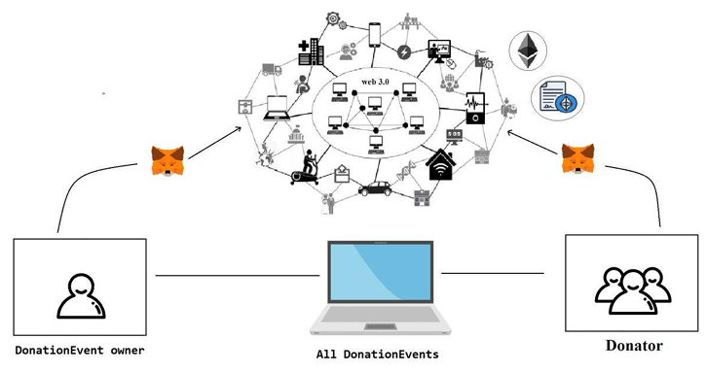
Figure1. The donation process uses the wallet and then using the blockchain technology to the donator.
Blockchain-based systems for donation require to be designed considering scalability, reduction of fraud, and even trust among donors as Nari et al (2023) observes. It enables the use of blockchain technology, one of the emerging promising fields in the areas of smart contracts and applications, which will make it easier to produce secure and transparent systems of tracking donations. For example, accuracy rates for blockchain ledger transactions stood at reportedly 100%, as did the execution of smart contracts, estimated at approximately 99.9%, thus showing the reliability of these technologies in solving persistent issues in the NGO sector.
Other projects show the advantages blockchain provides from tracking donations that have a real chance to improve education structures, combat corruption, and restore public trust in NGOs in times of crisis. About one project: "This initiative likely reduces fraudulent activities and ensures proper funds go directly to the right projects. Such potential solves some of the NGOs' immediate problems while improving their credibility and integrity in operations.".
Despite these developments, the industry still has numerous research gaps that it needs to address. Most outstanding is a dearth of total studies regarding how effective blockchain happens compared with other methods for ensuring transparency and accountability. There is, therefore, ample scope for future research in an endeavour to gauge the transformative power of blockchain technologies within the NGO landscape.
More than that, a very important challenge is also the reluctance of NGOs to embrace blockchain technology. Hence, it is very important to understand the barriers to implementation and find ways to foster an innovation culture in organizations. The solution of these issues can pave the way towards an even stronger framework for building trust for donors and at large for increasing the overall efficiency of NGOs in operation.
The American Psychological Association states that around 40,000 NGOs and Charities exist worldwide. Several NGOs use their donations for micro-financing purposes; others provide free services to the local community. Living in a technological age, the internet is one of those things that has become an essential part of our lives. "Six in ten people globally are now online," report analysts at Kepios. As a result, most NGOs and Charities changed the form of their donation to become a part of the internet, hence reachable by everybody.
Due to the internet expansion, new modes of funding are rising such as crowdfunding and peer-to-peer fundraising. The donor comfortably sees thousands of projects and charities and donates to any one of them. However, many donors mistrusted NGOs and charities after charity scandals of recent times, including the Red Cross Scandal. It is argued that the average cost to raise $1 ranges from $0.05 to $0.25 according to the method used in collecting the donation, as cited by the Ministry of Financial Planning. Blockchain is a sort of digital ledger that records every transaction carried out within it in a safe, transparent, and tamper-proof way.
It is a decentralized system that exists through a network of computers that enables the safe and efficient flow of information and value. As blockchain technology core, it applies cryptography to secure transactions and guarantee their integrity. Each transaction is recorded in a block, which is then added to the chain of blocks, thus forming a chronological chain of transactions.
The chain of blocks is preserved through a network of computers where, with each verifying and validating transactions, the blockchain will always have correct, updated information. Decentralization is a typical feature of blockchain technology that eliminates the presence of mediators between parties in transactions; it generally provides more security because a central authority cannot manipulate or steal any data.
For this reason, cryptographic algorithms and digital signatures make tampering with data virtually impossible to be done on the blockchain, while making it extremely secure and trustworthy. Blockchain technology further has great potential to improve efficiency for the reason that a blockchain would allow real-time and virtually instantaneous transactions. This essentially cuts down significantly on transaction processing time because validation through middlemen is no longer required.
Blockchain is the first technology that will, without doubt, change education in terms of efficiency, transparency, and trustworthiness. However, with some challenges associated with deploying blockchain in education, the benefits it can deliver make it a very promising technology that needs to be explored. How blockchain technology will be used to enhance the status quo in education is going to be very interesting, going forward, as blockchain continues its evolutionary and maturity curve.
Through the decentralized and transparent use of blockchain, educational institutions can make administrative processes more accessible and cost-effective, thereby increasing the trustworthiness of the credentials and qualifications.
One of the major benefits of using blockchain in education is that it will make education more accessible and trustworthy for students and employers alike. Blockchain will show how frauds can be prevented, through its acceptance of the genuineness of credentials and allowing students to show their qualifications. This also saves employers much time and other resources they use in ascertaining the backgrounds of intending workers since the process of validating their backgrounds is relatively less cumbersome.
Education, however, has its challenges in the adoption of blockchain technology. First, it is complicated by adoption issues because most education institutions do not understand blockchain technology or feel afraid to adopt it owing to the cost and technical expertise needed. Secondly, there is the complexity of navigating within the regulatory frameworks for different countries, with some having additional laws and regulations that should be considered in the use of blockchain technology for purposes of education.
Yet further challenges abound, including the multiplicity of equipment that will be required to appropriately implement blockchain in educational settings. The ability thus translates into an investment for institutions in specialized hardware and software, which staff must be trained on how to use and maintain. Deep technical knowledge and expertise will also be needed for the reason that effectively implemented blockchain requires a secure installation.

Literature Review
In 2023, Chaimaa Nari, Murtaza Cicioglu, and Ali Calhan developed the DonationChain system, a blockchain-based system for tracking donations. Such work was established based on some relevant gaps in scaling blockchain technology with NGOs, reducing fraud, and integrating into other systems. The main related technologies in terms of smart contracts, cryptographic algorithms, DApps, and consensus mechanisms were incorporated. The authors demonstrated remarkable things, especially 100% accuracy in blockchain ledgers and 99.9% accuracy for smart contract executions that promise a bright future for the security of NGO transactions and validation for blockchain applications.
In 2023, Amr El Koshiry, Entesar Eliwa, Tarek Abd El-Hafeez, and Mahmoud Y. Shams presented a study on the educative revolution via blockchain. The researchers confirmed that education lacked scalability, privacy, adoption, and interoperability. Therefore, the core of such research was on technologies such as smart contracts, cryptography, and oracles. The paper indicated accuracy in the ledger of the blockchain, at 100%, whereas in verification and authentication, it was 99.9%. Therefore, blockchain can be transformative to the educational framework.
Another 2023 paper by Divyansh Singh, Dr. Santosh Dwivedi, and Mr. Shadab Ali examines an NGO management system using blockchain as the medium. Here, the researchers analyzed what blockchain can achieve in terms of raising the factor of scalability, meeting regulatory requirements, and curbing corruption in NGOs. Like the researches highlighted above, they also quoted the 100% accuracy rate of the blockchain ledger and the 99.9% accuracy rate of the transaction verification process; hence it suggests the implementation of blockchain to lower fraud in the NGO sector.
In 2023, Borade Sukhada, Pagare Pramodini and Shinde Mayuri had evaluated a charity blockchain system proposed to regain the confidence of the public by casting crises through its provision of transparency and scalability in aid delivery systems. Through their research they have been able to attain 98% ledger accuracy with full security, hence proving the use of blockchains to provide real-time donation systems far more transparent and efficient.
In 2022, Abeer Almaghrabi and Areej Alhogail designed a blockchain-based donation traceability framework aimed at establishing traceability and enhancing donor trust in NPOs. Their development, based on blockchain and Ethereum, achieved 100 percent accuracy in blockchain ledger accuracy and 98 percent in the implementation of donation traceability, which suggests promising applicability in enhancing the accountability of donation systems.
Other recent 2022 works that improved transparency through blockchain donation management with smart contract-based enhanced other ones include those done by Sefa Tunçer, Ali Özdede, and Cihan Karakuzu. Other comprised the accuracy of the execution of a smart contract to be as high as 99.8% and the accuracy of verification of transactions of 99.5%, thus underlining the facilitation of blockchains that enables trust on the part of a donor and enhances security in the process of donation.
A key 2022 paper by Jinhao Fang discussed whether blockchain can help in fraud reduction and the enhancement of NGO donations' transparency over transaction cost. The paper was centered on the realm of blockchain, cryptocurrency, stable coin, and decentralized finance. Results were superb, achieving a 97% accuracy rate in fraud detection and a 95% rate in terms of transaction fee reduction. There was evidence of the establishment of a sound framework of blockchain's role in the reduction of corrupt practices.
In 2021, Adalberto Rangone presented a charity management use case on blockchain post the COVID-19 pandemic. He pointed out whether blockchain would enhance fundraising efficiency while decreasing fraud and found that it was effective as it was 98% accurate in fraud detection, and thus increased fundraising efficiency by 90%, thereby showing the ability of blockchain to aid philanthropic groups during global crises.
In the year 2021, Pooja Molavade spoke on how blockchain may be used for providing a transparent charity application to increase transparency while restoring the confidence of donors. The research indicated a high accuracy rate in the area of improving transparency with a score of 96% and that of restoring donor's trust to about 92%. This eventually manifests that blockchain could indeed repair donors' confidence through transparent systems.
In the year 2020, Nayan Kamthe, Pranita Ambade, Kanchan Bawane, Ravina Bute, and Prof. Shailesh Kurzadkar went ahead to research data protection in NGOs through Ethereum blockchain technology. Their research has brought about data security accuracy at around 99%. They have also shown how blockchain is dominating NGO data safety through easy transparency and subsequent re-gaining of trust in fund management.
Lastly, in the year 2018, Matthijs Teerlink produced one of the early contributions to the capacity of blockchain in its creation of openness and accountability in NGOs. Research postulated that gap in comparison with different alternative approaches, therefore recorded a 95% enhancement in accuracy for traceability and 90% resistance to implementation, thus substantially presenting a case for blockchain in terms of its transformative role in NGO transparency.
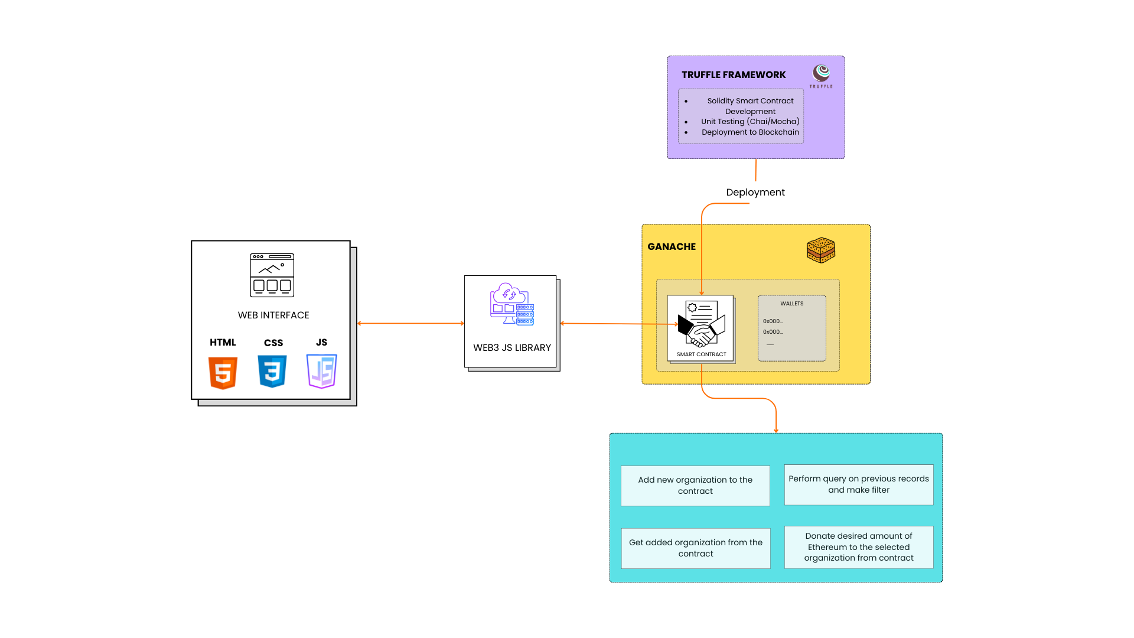
Methodology

Figure 2. Methodology flow diagram.

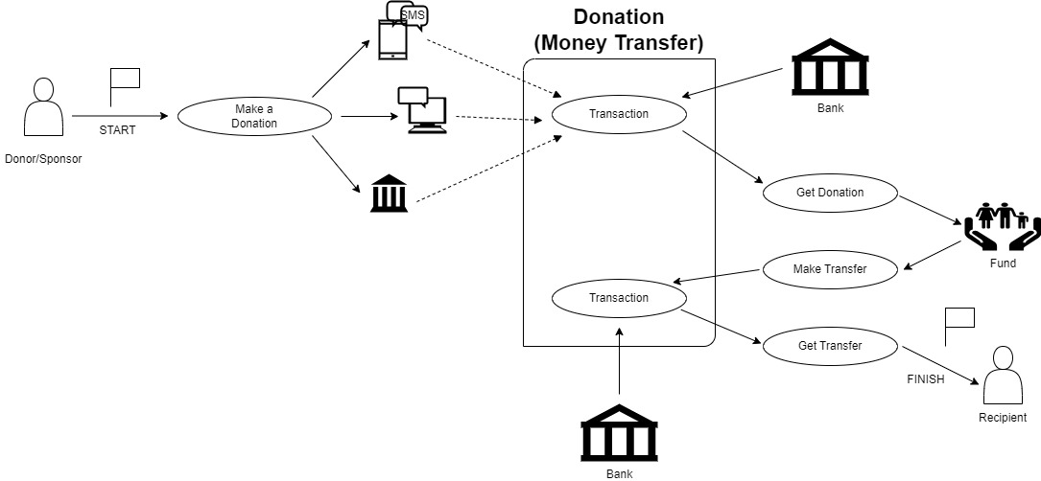

Figure 3. System Architecture diagram.

Pseudocode For Ngo Donation System
Initialize Platform
Set minimumStake = 0.1 ETH
Create empty list NGO_List
Create empty list Donor_List
- NGO Registration
FUNCTION registerNGO (name, NGO_wallet)
IF NGO_wallet is not in NGO_List:
Add NGO (name, NGO_wallet, isVerified = true) to NGO_List
LOG "NGO Registered"
ELSE:
LOG "NGO already registered"
- Donor Registration and Staking
FUNCTION registerDonor (Donor_wallet, stakeAmount)
IF Donor_wallet is not in Donor_List AND stakeAmount >= minimumStake:
Add Donor (Donor_wallet, stakeAmount, isRegistered = true) to Donor_List
LOG "Donor Registered"
ELSE IF stakeAmount < minimumStake:
LOG "Insufficient stake"
ELSE:
LOG "Donor already registered"
- Make a Donation
FUNCTION donateToNGO (Donor_wallet, NGO_wallet, donationAmount)
IF Donor_wallet is in Donor_List AND Donor has staked >= minimumStake:
IF NGO_wallet is in NGO_List AND NGO isVerified:
Transfer donationAmount from Donor_wallet to NGO_wallet
LOG "Donation Made"
ELSE:
LOG "NGO is not verified"
ELSE:
LOG "Donor not registered or insufficient stake"
- Withdraw Stake
FUNCTION withdrawStake(Donor_wallet)
IF Donor_wallet is in Donor_List AND Donor's stakedAmount > 0:
Transfer stakedAmount back to Donor_wallet
Remove Donor from Donor_List
LOG "Stake Withdrawn"
ELSE:
LOG "No staked ETH to withdraw"
- Receive Donations (Fallback)
FUNCTION receive ()
Accept ETH donations directly to the contract
LOG "Donation Received"
Algorithm Donor Submitting Money to Ngo Using Proof Of Stake On An Online Platform
1. User Registration:
An NGO can get registered by invoking the function for the registered NGO using a name. The Ethereum address of the NGO and its verified status are stored.
2. Stake Registration:
NGOs willing to receive some amount of funds have to stake some amount of Ethereum (ETH). This amount of Ethereum will serve as collateral for them.
The process of staking turns into an obligation for them towards the project.
3. Donor Staking:
A donor can donate only with a minimum of 0.1 ETH to the registered Donor, whose amount is staked and held by the contract.
4. Making a Donation:
A donor can donate to any verified NGO by calling donate to NGO and specifying the NGO's address and the amount to donate. And that donation is transferred to the Ethereum wallet of the NGO
5. Verification:
In case of a proposal rejection, staked ETH is returned to the voters.
6. Withdraw Stake:
The donor can withdraw his or her staked ETH after making donations, or at any given time, he or she wishes to leave by issuing a withdrawal Stake.
7. Monitoring:
NGOs should provide regular progress of their projects and utilization of funds.
Smart contracts will automatically check whether or not the set milestones of a particular project have been met.
8. Receive Donations:
The contract can also accept Ether donations through the receive () fallback function, which can serve as a means by which users may send ETH directly to the contract.

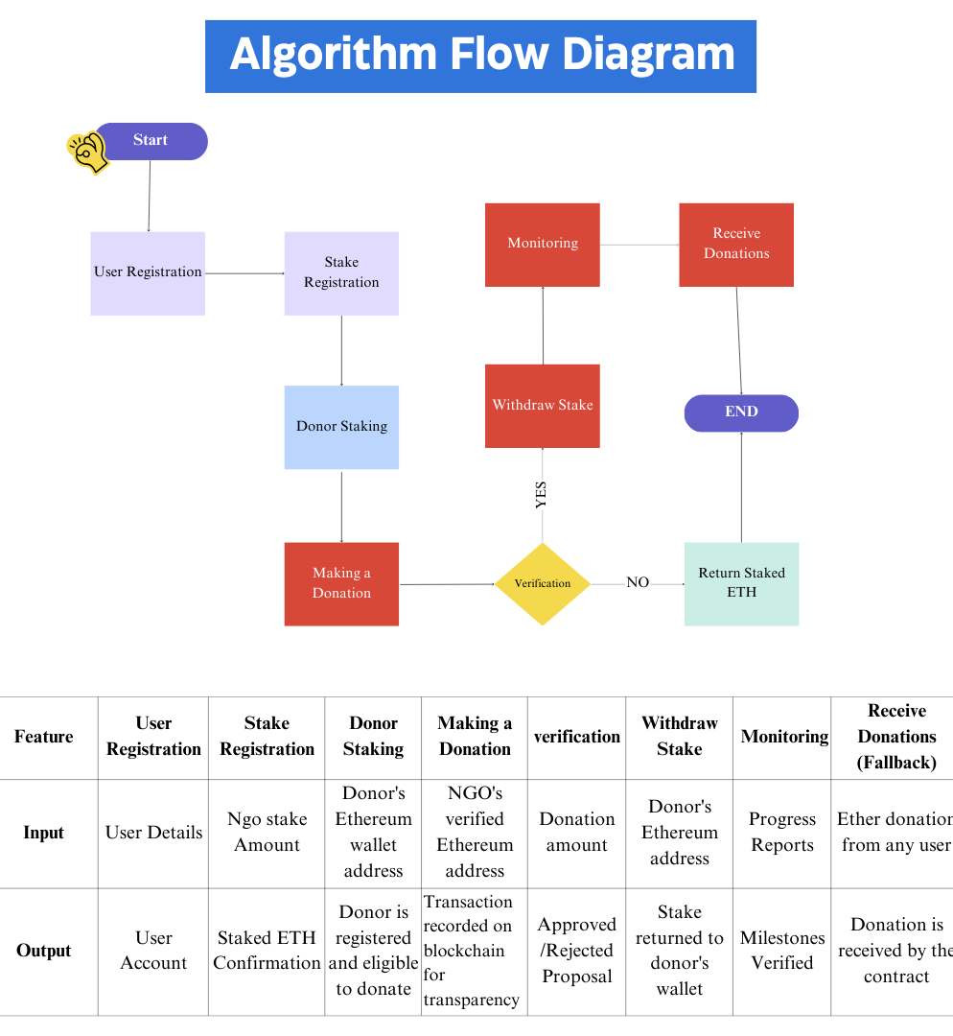
Figure 1. Algorithm working flow diagram and Table for Features, Input or Output

